Фундаментальный анализ как составной элемент Equity Research

Article by Dheeraj Vaidya, CFA, FRM

What is Equity Research?
Equity Research primarily means analyzing the company’s financials, perform ratio analysis, forecast the financial in excel (financial modeling), and explore scenarios with the objective of making a BUY/SELL stock investment recommendation. Equity Research analyst discusses their research and analysis in their equity research reports.
You are free to use this image on your website, templates etc, Please provide us with an attribution link
In this in-depth article on Equity Research, we discuss the nuts and bolts of Equity Research.
- Role of Equity Research
- Hierarchy in Equity Research firms
- Role of Head of Research
- Job of the Senior Analyst
- Responsibilities of an Associate
- Responsibilities of a Junior Analyst
- Typical Day at an Equity Research Firm
- Who pays for Equity Research?
- Equity Research Professional Approach
- Equity Research Skills-Set
- Top Equity Research Firms
- Equity Research Compensation
- Equity Research Exit Opportunities

WallStreet Equity Research
https://www.wallstreetmojo.com/equity-research/
Equity Research explan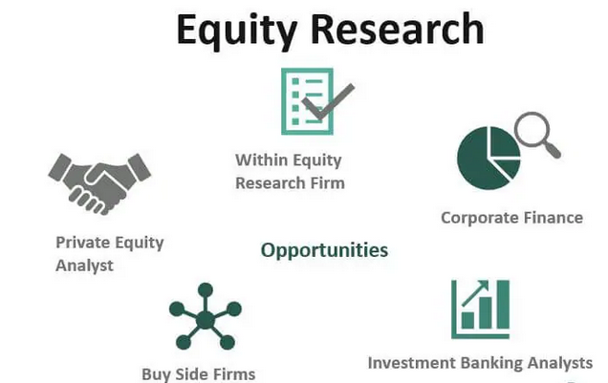ation is quite simple. Let us look at these steps below

- Equity research is all about finding the valuation of a listed company (Listed companies trade on a stock exchange like NYSE or NASDAQ etc
- Once you have the company under consideration, you look at the economic aspects like GDP, growth rates, the market size of the industry and the competition aspects, etc.
- Once you understand the economics behind the business, perform the financial statement analysis of the historical balance sheet, cash flows, and income statement to form an opinion on how the company did in the past.
- Based on management’s expectation, historical performances, and industry competition, project the financial statements like the BS, IS, and CFs of the company. (also called as Financial Modeling in Equity Research)
- Use the Equity valuation models like DCF, Relative valuations, a sum of parts valuation the company.
- Calculate the Fair price based on the above models and compare the fair price with the Current Market Price (stock exchange)
- If the Fair Price < Current Market Price, then the company stocks are overvalued and should be recommended as a SELL.
- If the Fair Price > Current Market Price, then the company shares are undervalued and should be recommended as a BUY.

Role of Equity Research
- Equity Research plays a very critical role that fills the information gap between the buyers and sellers of shares.
- The reason is that at all levels (individual or institutional) may not have the resources or the capabilities to analyze every stock.
- Additionally, full information is not provided by the management due to which further in-efficiencies are created and stocks trade below or above the fair value.
- Equity Research analyst spends a lot of time, energy, and expertise to analyze stocks, follow the news, talking to the management, and provide an estimate of stock valuations.
- Also, equity research tries to identify the value stocks out of the massive ocean of stocks and help the buyers to generate profits.

What is the Typical hierarchy in Equity Research firms?
- A typical hierarchy at an Equity Research firm starts with the Head of Equities/Head of Equities at the top.
- Thereafter there are Analysts (senior) covering different sectors. Each analyst mostly covers around 10-15 companies in a specific sector.
- Each Senior analyst may be supported by an Associate, who in turn, may be supported by a couple of Junior Analysts.
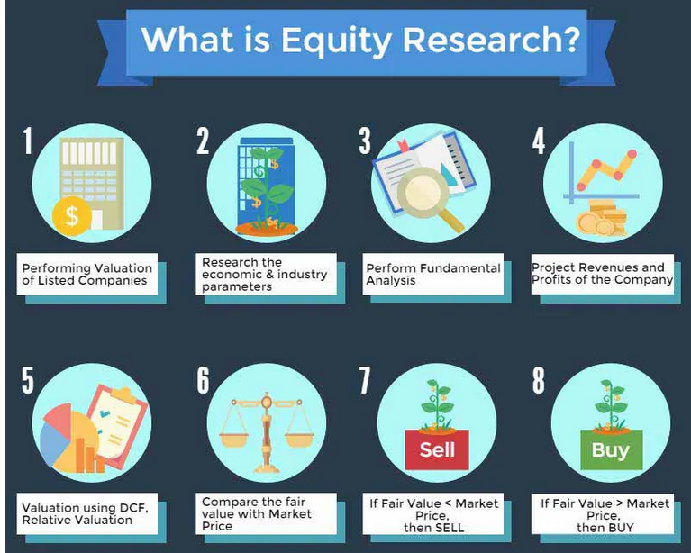

What is the role of the Head of Research?
- Head of Research acts as a key member to manage the Equity research analyst team, providing the team with leadership, coaching, and guidance to ensure that the brokerage goals and objectives are met.
- They oversee research reports, publications; it’s editing as well as monitor the process of analysis and brokerage recommendations.
- They ensure that adequate support is provided to sales and trading teams.
- Contribute to Equities by providing expert-level inputs for overall strategy, goals, initiatives, and budgets
- Responsible for Analyst hiring, compensation, development, and performance management
- Liaison with fund managers and the research teams

What is the job of the Senior Analyst?
Below is an excerpt from a job requirement of a Senior analyst –

source – FederatedInvestor
- Typically an equity research senior analyst would cover a sector with not more than 8-15 stocks. Coverage implies tracking these stocks actively. Senior Analyst tries to bring maximum companies under coverage in the sector he/she tracks (initiating the coverage)
- Many senior equity analysts cover companies that investors may want to invest in. These companies are like the high market capitalization companies or the ones with higher trading volume, and there could also be cases where investors want to invest in small-cap or mid-cap stock companies with fewer analysts coverage.
- One of the most important responsibilities of Senior Analyst is to come up with Quarterly Results Update – results summary, expectation, and performance against those expectations, updating forecasts, etc.
- Talking to the clients (buy side) and showcasing their calls on the stocks. They have to diligently communicate buy sell recommendations of stocks. Additionally, they have to articulate clearly why a certain stock should be included in their portfolio.
- Write important industry event updates like conferences or management meeting updates.
- To update the Sales team, dealing with and trading team about the latest news in the sector and the company, and keep them updated with the brokerage’s view on the same.
- Attending conference calls for important company updates, results, etc
- Attend trade shows, meet company management, suppliers meetings, etc

Responsibilities of an Associate
Below is the summary of the Associate job description from efinancialcareers

- The primary job of an associate is to support the Senior Analyst in the best way possible.
- An associate has prior experience of around 3 years or so in a similar industry.
- Updating the financial model, verifying the data, and preparing the valuation models
- Working on various client requests like a request of data, industry analysis, etc
- Prepare draft Equity Research Reports (update of results, events, etc.)
- Work on client requests
- Participate in meetings and calls with clients on the stock under coverage.

Responsibilities of a Junior Analyst
Here is a snapshot of Junior Equity Analyst’s responsibilities.

source – careers.societegenerale.com
- The main responsibilities of Junior Analyst are to support the Associate in every format.
- The majority of the work done by Junior Analyst is related to data and excel etc.
- Also, Junior Analyst may be involved in doing primary research, industry research, coordinating with clients, etc.
- Maintaining the industry database, charts, graphs, and financial models, etc.

Typical Day at an Equity Research Firm
Previously, I had worked with companies like JPMorgan and CLSA India as an Equity Research Analyst. I covered Indian Oil & Gas sectors with stocks like ONGC, BPCL, HPCL, GAIL, etc. Below was my typical day as an Equity Research Analyst.
7:00 am – Reach office
- Check emails from traders and salespeople
- Check the stock markets (Asian Markets that open first)
- Check for all the news related to your sector
7:30 am – 8:00 am Attend Morning Meeting
- Morning meeting is nothing a formal discussion of the recommendations before the market opens along with Sales & Trading Team
- In this morning meeting, all analysts present their views on key developments in their sector along with the Head of Research or Equities presenting their views on the general markets.
9:00 am – Market Opens
- Follow the Market, look for key developments in your sector
- Try to rationalize if there are any rapid stock price movements
10:00 am – Regular Work
- Perform regular research analyst duties like Client Requests, Financial Model updates,
- Follow the News and keep a close check
11:00 am – Regular Work / Client Discussions
- Discussion with buy side clients for any explanation of research/calls
- Continue doing your regular maintenance work
3:30 pm – Market Closes
- Capture the market movements of the company under coverage for the day closure.
- Check if there is anything that the clients should know and work accordingly.
4:00 pm – Work on New Research Publications
- Work on the new research piece for publication (next day or in coming days)
- Generally, research analyst targets at least 1 to 2 research pieces every week.
7:30-8:00 – go Home
- If there is no earning season (company results), then the typical go home time is 7:30-8:00 pm. However, during earning seasons, there is no surety when you will reach home.
- You need to fully prepare the result update report and keep it ready for the next day early morning publication.

Who Pays for Equity Research?
- For Independent Equity Research firms: Independent equity research firms do not have a trading and sales division. They perform financial analysis with an idea of charging Fees on a per report basis. Also, see Equity Research vs. Sales and Trading.
- For Major Equity Research firms: Fee income is earned by brokerage trades (Soft Dollars). To understand this in detail, let us look at the diagram below –
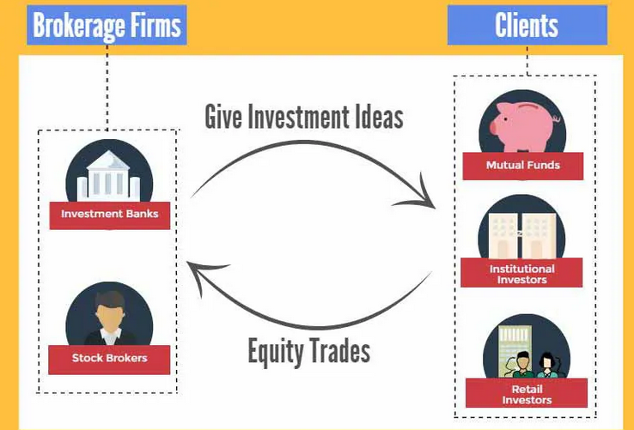
- As noted above, on one side is the Buy Side firms like Hedge Funds, Pension Funds, Insurance Companies, Mutual funds, etc.
- On the other side are the sell side firms like JPMorgan, Goldman Sacks, Credit Suisse, etc.
- The buy side firms manage the portfolio, and they are required to invest their portfolio as per the investment objective.
- Investment objective may mandate these companies to keep a portion of their assets in Stocks etc.
- In such cases, the buy side analysts seek to advise from the sell side analyst for investment decisions.
- The advice or the idea provided by the sell side analyst is literally for FREE.
- Once the buy side analyst has taken the decision of investing in the stock, the buy side analyst may look forward to executing the trade through the Trading division of the sell side firm.
- The trading division will, in turn, charge a commission for executing the trade at the lowest price.
- The commission, in return, is basically the earnings of the research firms.

Equity Research Professional Approach
So what is your work like as an Equity Research Professional? Equity Research analysts follow stocks and make recommendations on whether to buy, sell, or hold those securities using Fundamental Analysis. Equity Research is a very challenging job, where an analyst may be required to spend more than 12-14 hours a day.
For creating a professional Equity Research Financial model, an expert analyst recommended approach is as follows –

Economic Analysis / Industry Analysis / Company Analysis
- The very first thing you need to take care of while doing a professional analysis is to learn about the economic parameters affecting the industry, the industry dynamics, competitors, etc.
- For example, when you are analyzing Alibaba, you should know about each and every subdivision of Alibaba and its competitors.
- 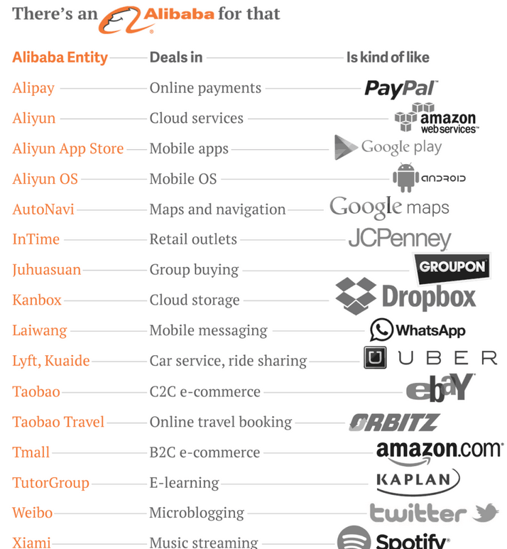

Fundamental Analysis
- You should be awesome at Fundamental Analysis. Fundamental Analysis means performing a Ratio Analysis of the company under consideration.
- Before you start ratio analysis, you should populate at least the last 5 years of financial statements (Income Statement, Balance Sheet, and Cash Flows) in excel.
- You should prepare a blank excel sheet with Separate Income Statement, Balance Sheet, and Cash Flows and use neat formats.
- Populate the historical financial statements (IS, BS, CF) and do the necessary adjustment for Non-recurring items (one time expenses or gains).
Do the Ratio Analysis for Historical years
- An example is presented below in Colgate Ratio Analysis
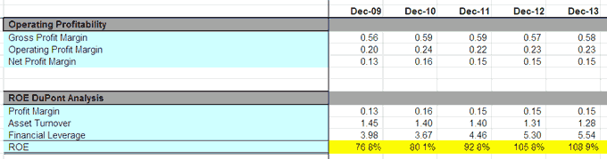

Preparing a Professional Financial Model
- Company management does not provide the future financial projections of the company. Therefore, it is important as a research analyst to project this data. Forecasting the financials of the company is known as Financial Modeling. I earlier wrote a 6000 words step-by-step tutorial on Financial Modeling. If you want to master Financial Modeling, you can refer to this Financial Modeling Tutorial
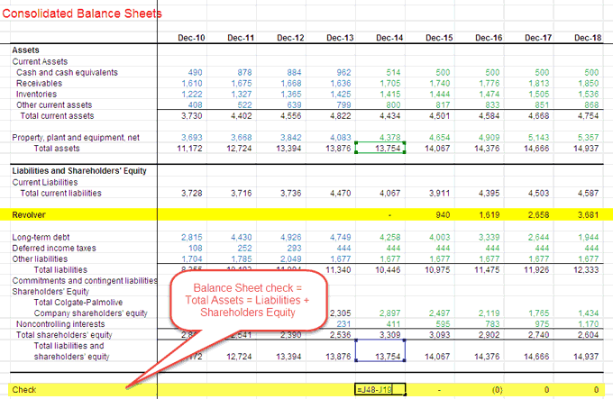

Valuations – DCF
- Valuation is primarily done using two methods – a) Discounted Cash flow and b)Relative Valuations.
- Once your financial model is ready, you can perform Discounted cash flows as given in the steps below –
- Calculate FCFF as discussed in class and the handbook
- Apply a suitable WACC post the calculation of the capital structure
- Find the Enterprise Value of the Firm (including the Terminal Value)
- Find Equity Value of the Firm after the deduction of Net Debt.
- Divide Equity Value of the Firm by the total number of shares to arrive at the “Intrinsic Fair Value” of the company.
- Recommend whether to “BUY” or “SELL”

Valuation – Relative Valuations
- Relative valuation is based on comparing the valuation of the company under consideration with the valuation of other firms. There are valuation multiples used to value companies like PE Multiple, EV/EBITDA, PBV ratio, etc.
The common approach is given below.
- Identify the comparable based on the business, Market Capitalization, and other filters.
- Identify a suitable trading valuation multiple to be used for this business.
- Use the average valuation multiple to find the valuation of the company.
- Suggest “Undervalued” or “Over-valued.”

Research Report
- Once you have prepared the financial modeling and find the fair valuation of the company, you need to communicate this to your clients through Research Reports. This research report is very professional in nature and is prepared with a lot of caution.
- Below is a sample of the Equity Research Report. You may learn about Equity Research Report Writing here.https://www.wallstreetmojo.com/wp-content/uploads/2015/03/Reliance-Petroleum.pdf

Equity Research Skills-Set
Here are excerpts from the Equity Research Job Requirements Description –

Key highlights to note from this excerpt is –
- MBA is a plus (not a necessity). If you are an MBA, then you have certain advantages, but if you are a graduate, you should not get disheartened. You have a chance if you prove your interest in finance. Please do have a look at Can an engineer get into an Investment Bank.
- Financial discipline is not essential, but you must have a strong interest in the financial markets with excellent quantitative and analytical skills.
- You should be fluent in English and have excellent verbal and written communication skills.
- You possess intellectual curiosity, focus, and creativity, and have a keen research instinct with creative problem-solving abilities.
- Strong proficiency in Microsoft Excel and Powerpoint
- CFA designation – This is one important designation that the finance industry respects. Try to ensure that you take the CFA examination and pass at least a couple of levels.
- I wrote a detailed post on the skills required to enter into Equity Research. My top 5 skillsets required to enter the Equity Research Industry are –
- Excel Skills
- Financial Modeling
- Valuations
- Accounting
- Report Writing
You can get an in-depth understanding of the skillsets here – Equity Research Skills.

Top Equity Research Firms
Institutional Investors ranking suggests that in 2014, the best research firm was Merril Lynch Bank of America, second place was taken by JPMorgan, and Morgan Stanley came third.
Apart from the top 3 above, there are other notable equity research firms (listed below)
Deutsche Bank | Standard Chartered Bank
Credit Suisse | Cornerstone Macro
UBS | Wolfe Research
Barclays | BNP Paribas Securities
Citi | CIMB Securities
Nomura | Cowen and Co.
Goldman, Sachs & Co. | Berenberg Bank
CLSA Asia-Pacific Markets | Citic Securities
Wells Fargo Securities | CRT Capital Group
VTB Capital | Empirical Research Partners
Sberbank CIB | J. Safra Corretora
Santander | Keefe, Bruyette & Woods
ISI Group | Kempen & Co.
Daiwa Capital Markets | Otkritie Capital
Jefferies & Co. | Raymond James & Associates
Mizuho Securities Group | Renaissance Macro Research
SMBC Nikko Securities | SEB Enskilda
Macquarie Securities | ABG Sundal Collier
HSBC | Amherst Securities Group
Banco Português de Investimento | Antique Stock Broking
Batlivala & Karani Securities India | Autonomous Research
BBVA | Helvea
BGC Partners | Ichiyoshi Research Institute
BMO Capital Markets Corp. | ICICI Securities
BOCI Research | ING Financial Markets
Brasil Plural | Intermonte
Commerzbank Corporates & Markets | JB Capital Markets
Davy | Kepler Capital Markets
EFG-Hermes | LarrainVial Corredora de Bolsa
Equita S.I.M. | Lazard Capital Markets
Fidentiis Equities | MainFirst Bank
Gazprombank | N+1 Equities
Goodbody Stockbrokers | Oddo Securities
Guggenheim Securities | Okasan Securities Co.
Handelsbanken Capital Markets | Oppenheimer & Co.
Samsung Securities | Petercam
Stifel | Rabobank
Strategas Research Partners | Redburn Partners
UniCredit | Washington Analysis
Vontobel | Zelman & Associates

Equity Research Compensation
- Junior Analyst/Assistants have a base comp of $45,000 – $50,000 per year (average)
- Associates have a base salary of $65,000 – $90,000 per year (average) depending on the experience. Additionally, they get a bonus of 50-100% of the base salary (in an average to good year)
- Senior Analysts generally have a base compensation of $125,000 – $250,000. Their bonus may range from 2-5 times the base compensation.

Equity Research Exit Opportunities
Sell Side research analyst has various Career Opportunities –

Within Equity Research Firm
- If you joined as an associate, then you can move up the ladder to become a Senior analyst assuming full responsibility for the sector coverage.
- Later you can move further up to become Head of Research and Head of Equities.

Private Equity Analyst
- Sell side analysts also move to the Private Equity domain working as Private Equity Analyst.
- Instead of analyzing public companies, they analyst private companies from the point of view of investments.
- They can move up the hierarchy to become a Private Equity Fund manager. Check out the list of Top Private Equity Firms.

Investment Banking Analysts
- Movement of sell side analysts to Investment banking is slightly tough but not impossible.
- Sell side analysts are fully aware of financial research and modeling related work.
- What they haven’t worked on is the transaction-related work like IPO filing documents, Pitch books, registration work, etc. If you are confused between Investment Banking and Equity Research, read this article – Investment Banking vs. Equity Research.

Buy Side Firms
- Sell side analysts sometimes are also absorbed as buy side analysts (working for Mutual funds, etc.).
- The buy side analysts assume the responsibility of fund managers over a period of time.

Corporate Finance
- Sell side analysts work a lot on financial analysis, analyzing company projects, and its effect on the overall company’s financials. Hence, they get into typical Corporate finance roles of large corporates (take care of financial analysis, planning Projects, etc.)
- Another unique role they get into is Investor relations. As a sell side analyst, they get equipped with the FAQs and how to deal with critical information and its sharing, etc. Due to this, they also become eligible for Investor Relations jobs.

Recommended Articles
- Equity Research Interview Questions

Conclusion
Equity Research essentially means preparing an estimate of company fair valuation for recommending the buy side clients. Though, as a research analyst, you may spend 12-16 hours a day at the office; however, this is a dream job for many who love Finance and Financial Analysis. If you like to work in a challenging and dynamic environment, then this is one career you must consider. Not only equity research job rewards analysts with relatively higher compensation, but also, it provides excellent exit opportunities.

#1 – What are Financial Statements of a company and what do they tell about a company?
Ans. Financial Statements of a company are statements, in which the company keeps a formal record about the company’s position and performance over time. The objective of Financial Statements is to provide financial information about the reporting entity that is useful to exist and potential investors, creditors, and lenders in making decisions about whether to invest, give credit or not. There are mainly three types of financial statements which a company prepares.
1. Income Statement – Income Statement tells us about the performance of the company over a specific account period. Financial performance is given in terms of revenue and expense generated through operating and non-operating activities.
2.Balance Sheet – Balance Sheet tells us about the position of the company at a specific point in time. Balance Sheet consists of Assets, Liabilities and Owner’s Equity. Basic equation of Balance Sheet: Assets = Liabilities + Owner’s Equity.
3.Cash Flow Statement – Cash Flow Statement tells us the amount of cash inflow and outflow. Cash Flow Statement tells us how the cash present in the balance sheet changed from last year to the current year.

#2 – Explain Cash Flow Statement in detail
Ans. Cash Flow Statement is an important financial statement that tells us about the cash inflow and cash outflow from the company. Cash Flow can be prepared by the Direct method and Indirect method. Generally, the company uses the Direct method for preparing the Cash Flow Statement as seen in the annual report of the company. The direct method starts with cash collected from customers adding interests and dividends and then deducting cash paid to suppliers, interest paid, income tax paid. The indirect method starts from net income and then we add back all the non-cash charges which are depreciation and amortization expense, we also add working capital changes.
Cash Flow Statement is categorized into three activities: Cash Flow from Operations, Cash Flow from Investing and Cash Flow from Financing.
Cash Flow from Operations consists of cash inflows and outflows which are generated from the company’s core business or product. Cash Flow from Investing consists of the cash inflows and outflows from a company in the form of investments like purchase or sale of PP&E (property, plant & equipment). Cash Flow from Financing consists of cash inflows and outflows generated from all the financing activities of the company like issuance of Bonds or early retirement of Debt.
Let us move to the next Corporate Finance interview question.

#3 – Explain three sources of short-term Finance used by a company
Ans. Short-term financing is done by the company to fulfill its current cash needs. Short-term sources of finance are required to be repaid within 12 months from the financing date. Some of the short-term sources of financing are: Trade Credit, Unsecured Bank Loans, Bank Over-drafts, Commercial Papers, Secured Short-term loans.
- Trade Credit is an agreement between a buyer and a seller of goods. In this case, the buyer of the goods purchases the goods on a credit i.e. the buyer pays no cash to the seller at the time of buying the goods, only to pay at a later specified date. Trade credit is based on mutual trust that the buyer of the goods will pay the amount of cash after a specified date
- Bank Overdraft is a type of short-term credit that is offered to an individual or a business entity having a current account which is subject to the bank’s regulation. In this case, an individual or a business entity can withdraw cash more than what is present in the account. Interest is charged on the amount of over-draft which is withdrawn as a credit from the bank.
- Unsecured Bank Loan is a type of credit that banks are ready to give and is payable within 12 months. The reason why it is called an unsecured bank loan is that no collateral is required by the individual or a business entity taking this loan.

#4 – Define Working Capital
Ans. Working Capital is basically Current Assets minus Current Liabilities. Working capital tells us about the amount of capital tied up to its business (daily activities) such as account receivables, payables, inventory in hand and many more. Working capital can also tell us the amount of cash needed to pay off the company’s obligations which have to be paid off within 12 months.

#5 – A company buys an asset; walk me through the impact on the 3 financial statements
Ans. The purchase of Assets is a transaction done by the company which will impact all the three statements of the company. Let’s say that the asset is the equipment of $5million.
- In Balance Sheet, cash will go down by $5million; decreasing the asset side of the balance sheet and at the same time the asset will be recorded as equipment of $5million which will increase the asset side of the balance sheet by the same amount. Hence, the balance sheet of the company will be tallied.
- In Income Statement, there will be no impact on the first year of income statement but after the first year, the company will have to charge depreciation expense on the purchased equipment which the company will have to show it in the Income Statement of the company.
- Cash Flow Statement, assuming that only cash has been paid by the company to purchase the equipment. The Cash Flow from Investing will result in the cash outflow of $5million.

#6 – What is EPS and how is it calculated?
Ans. EPS is the Earnings per Share of the company. This is calculated for the common stockholders of the company. As the name suggests, it is the per-share earnings of the company. It acts as an indicator of profitability. Calculation:
EPS = (Net Income – Preferred Dividends) / weighted average number of shares outstanding during the year

#7 – Different types of EPS
Ans. There are basically three types of EPS which an analyst can use to calculate the company’s earnings: Basic EPS, Dilutive EPS, and Anti-Dilutive EPS.
- Basic EPS: It is useful for companies that have a simple capital structure. In other words, it can be used to calculate earnings of the company which has no convertible securities outstanding like convertible bonds or convertible preference shares.
- Dilutive EPS: It has a dilutive characteristic attached to it. When a company has a complex capital structure, it is better to calculate Dilutive EPS instead of Basic EPS. In other words, when a company has convertible securities such as convertible bonds, convertible preference shares and/or stock options which after conversion, dilutes the earnings i.e. lower the earnings calculated for common shareholders of the company.
- Anti-Dilutive EPS: This is the kind of EPS in which the convertible securities after conversion, increases the earnings for the common shareholders of the company.
Let us move to the next Corporate Finance interview question.

#8 – What is a difference between Futures Contract and Forwards Contract?
Ans. A futures contract is a standardized contract which means that the buyer or seller of the contract can buy or sell in lot sizes that are already specified by the exchange and is traded through exchanges. Future markets have clearinghouses that manage the market and therefore, there is no counterparty risk.
Forwards Contract is a customizable contract which means that the buyer or seller can buy or sell any amount of contract they wish to. These contracts are OTC (over the counter) contracts i.e. no exchange is required for trading. These contracts do not have a clearinghouse and therefore, the buyer or the seller of the contract is exposed to the counterparty risk.
Also, do check this detailed article on Forwards vs Futures

#9 – What are the different types of Bonds?
Ans. A bond is a fixed-income security that has a coupon payment attached to it which is paid by the bond issuer annually or as per the conditions set at the time of issuance. These are the types of bonds:
- Corporate Bond, which is issued by the corporations.
- Supra-National Bond is issued by super-national entities like the IMF and World Bank.
- Sovereign National Bond is a bond issued by the government of the country.

#10 – What is a securitized Bond?
Ans. A bond that is repaid by the issuing entity by the cash flows which come from the asset set as collateral for the bond issued is known as securitized Bond. We can understand by the example: A bank sells its house loans to a Special Purpose Entity and then that entity issues the bonds which are repaid by the cash flows generated by those house loans, in this case, it is the EMI payments made by the house owners.

>Part 2 – Corporate Finance Interview Questions (Advanced)
Let us now have a look at the advanced Corporate Finance Interview Questions.

#11 – What is Deferred Tax Liability and why it might be created?
Ans. Deferred Tax Liability is a form of tax expense that was not paid to the income tax authorities in the previous years but is expected to be paid in future years. This is because of the reason that the company pays less in taxes to the income tax authorities than what is reported as payable. For example, if a company uses a straight-line method for charging depreciation in its income statement for shareholders but it uses a double-declining method in the statements which are reported to income tax authorities and therefore, the company reports a Deferred Tax Liability as the paid less than what was payable.

#12 – What is Financial Modeling in Corporate Finance?
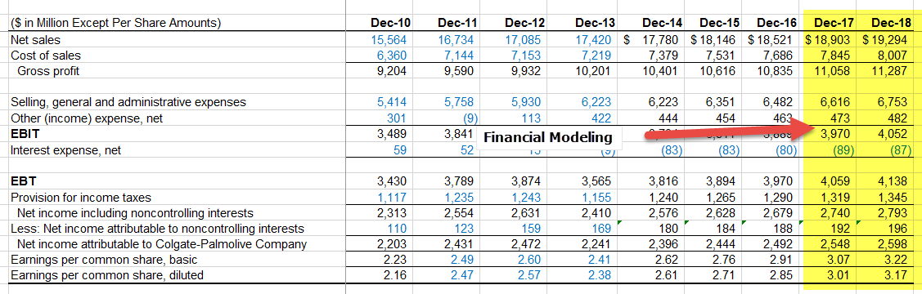
- First of all, financial modeling is a quantitative analysis that is used to make a decision or a forecast about a project generally in the asset pricing model or corporate finance. Different hypothetical variables are used in a formula to ascertain what future holds for a particular industry or for a particular project.
- In Corporate Finance, Financial modeling means forecasting companies financial statements like Balance Sheet, Cash Flows, and Income Statement. These forecasts are in turn used for company valuations and financial analysis.
- With respect to Investment Banking, you can talk about the Financial Models that you have prepared. You may refer to these Financial Modeling Templates.
Let us move to the next Corporate Finance interview question.

#13 – What are the most common multiples used in valuation?
There are few common multiples which are frequently used in valuation –
- EV/Sales
- EV/EBITDA
- EV/EBIT
- PE Ratio
- PEG Ratio
- Price to Cash Flow
- P/BV Ratio
- EV/Assets

#14 – Describe WACC and its components
Ans. WACC is the Weighted Average Cost of Capital which the company is expected to pay on the capital it has borrowed from different sources. WACC is sometimes referred to as the Firm’s Cost of Capital. The cost to the company for borrowing the capital is dictated by the external sources in the market and not by the management of the company. Its components are Debt, Common Equity, and Preferred Equity.
The formula of WACC = (Wd*Kd) + (We*Ke) + (Wps*Kps).
#15 – Describe P/E Ratio
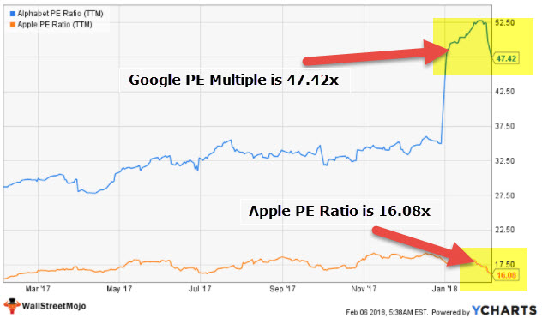
Ans. P/E Ratio also referred to as Price to Earnings Ratio is one of the Valuation Ratios which is used by analysts to see if the stock of the company is overvalued or undervalued. The formula is as follows P/E = current market price of the company’s stock divided by Earnings per Share of the company.

#16 – What are Stock Options?
Ans. Stock Options are the options to convert into common shares at a predetermined price. These options are given to the employees of the company in order to attract them and make them stay longer. The options are generally provided by the company to its upper management to align management’s interests with that of its shareholders. Stock Options generally have a venting period i.e. a waiting period before the employee can actually exercise his or her option to convert into common shares. A Qualified option is a tax-free option which means that they are not subject to taxability after the conversion. An Unqualified option is a taxable option which is taxed immediately after conversion and then again when the employee sells the stock.

#17 – What is the DCF method?
Ans. DCF is the DCF method. This method is used by analysts to value a company by discounting its future cash flow and bringing it down to its current value. Discounted Cash Flow uses different techniques to value a company. These techniques or methods are:
DDM, FCFF, and Free Cash Flow to Equity.
Let us move to the next Corporate Finance interview question.

#18 – What is a Stock Split and Stock Dividend?
Ans. A stock split is when a company splits its stock into 2 or more pieces. For example a 2 for 1 split. A company splits its stock for various reasons. One of the reasons is to make the stock available for the investors who invest in the stock of the companies which are inexpensive. The probability of growth for those stocks also increases. Stock Dividend is when the company distributes additional shares in lieu of cash as dividends.

#19 – What is the Rights Issue?
Ans. A rights offering is an issue that is offered to the existing shareholders of the company only and at a predetermined price. A company issues this offer when it needs to raise money. Rights Issues might be seen as a bad sign as the company might not be able to fulfill its future obligations through the cash generated by the operating activities of the company. One needs to dig deeper as to why the company needs to raise the capital.

#20 – What is a clean and dirty price of a bond?
Ans. Clean price is a price of a coupon bond not including the interest accrued. In other words, the clean price is the present value of the discounted future cash flows of a bond excluding the interest payments. Dirty price of a bond includes accrued interest in the calculation of bond. Dirty price of the bond is the present value of the discounted future cash flows of a bond which include the interest payments made by the issuing entity

